Spotsylvania County Democratic Committee
General Meeting Minutes
July 21, 2025
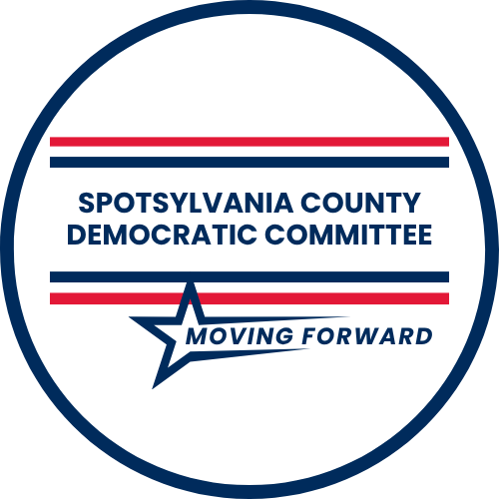

Jeffrey Kent • Chair
Debra Aldrich • Vice Chair
Candace Macken PhD • Secretary
Pat Carl • Treasurer

Meeting location: Park Lane Tavern, 1 Towne Centre Blvd, Fredericksburg, VA 22407.
The meeting was called to order at 6:05 PM.

The Spotsylvania Branch of the NAACP is sponsoring a series of events to introduce candidates at the state and local levels to constituents and to give voters an opportunity to hear their positions on the issues that directly affect our communities. More information on this and other sponsored events can be found at https://www.facebook.com/SpotsylvaniaBranchNAACP/ .
Four new members were approved by membership.
Ms Nicole Cole, candidate Virginia House of Delegates District 66, spoke about the importance of protecting funding for public school education, access to affordable health care and housing, and raising the minimum wage. In contrast, her opponent stands against womens’ reproductive rights, improvements in the regional transportation structure, and veterans.
The Vice Chair recognized the following distinguished visitors: Dr Carol Medawar, Spotsylvania County School Board; Ms Nicole Cole, candidate Virginia House of Delegates District 66; Ms Gabrielle Pickover, candidate Spotsylvania School Board Lee Hill District; Ms Jennifer Craig-Ford, candidate Spotsylvania School Board Battlefield District; Dr James King, candidate Spotsylvania School Board Battlefield District; Ms Nilofer Garza, candidate Spotsylvania Board of Supervisors Berkeley district; and Ms Mina Sumpter, Spotsylvania Branch NAACP.
A motion was made by Dr Medawar to approve June General Meeting minutes, seconded by Ms Jaimie Ashton. The minutes were approved by membership.
Treasurer’s Report July 2025
Deposits
Membership Dues | 225.00
Donation | 30.00
Donation, stamps | 100.00
Spotsy Dems T-Shirts | 85.00
Trivia Night | 540.00
Candidate BBQ | 2495.00
Total | $3475.00
Expenditures
FXBG July 4 | 50.00
Postcard Stamps | 100.00
Trivia Night | 439.00
Candidate BBQ | 794.00
Total | $1433.00

Thirty-three pounds of dry goods were donated to the Fredericksburg Area Food Bank in June, bringing the year-to-date food donation total to 536 pounds.
Three School Board candidates, Ms Craig-Ford, Dr King, and Ms Pickover, were invited to speak and answer questions posed by membership. Topics included addressing school violence, the role of for-profit organizations in education, ensuring the separation of church and state in schools, access to after-school activities and programs, and school board in-fighting.
The Vice Chair provided an update on Contest Every Race (CER) grant activity, which included the candidate BBQ, and plans for future activities.
Standing Committee progress reports were delivered by the respective chairs or their representatives. The Outreach Committee noted SCDC presence at the PRIDE parade and at the Fredericksburg July 4 celebration and announced plans to participate at the Virginia State Fair and the Fredericksburg Latin Festival in September. Co-chairs of the Fundraising Committee reported on the proceeds from Trivia Nights and the candidate BBQ, and plans for post-election fundraising activities. Precinct Operations announced that it has recruited district captains for each local voting district. However, volunteers are still needed to work precincts on Election Day, November 4. The Technology/Communication Committee reported that social media engagement numbers increased across all platforms. The Social Committee reported on its activities. In addition to the new members approved at this meeting, the Membership Committee stated that 50 people made application for membership at various events and that 50-plus persons were contacted by committee members.
The Vice Chair announced that an online survey will be launched to solicit the level of volunteer need in three areas: training on rules, regulations, and voter protection; developing materials to inform both volunteers and voters on the candidates and candidates’ legislative priorities; and information on SCDC’s outreach activities and accomplishments.
Volunteer of the Month citations were awarded to Ms Michelle Gooden and Ms Lizzie Heard.
The meeting adjourned at 7:45 PM.
Respectfully submitted,
Candace Macken PhD
Secretary

